



|  |
| --- |
|  |
| Capstone Project Document |

**Real Estate Website Management**

|  |  |
| --- | --- |
| **<SWR302_EstateLux>** | |
| **Group Members** | Ha Pham Cuong  Ha Van Quang  Nguyen Thanh Long  Hoang Duc Truong  Nguyen Trong Duy An |
|  | **Lecturer: Pham Ngoc Ha** |

MINISTRY OF EDUCATION AND TRAINING

- Hanoi, <Spring Semester>/<2021> -

**Acknowledgement**

Foremost, we would like to express our sincere gratitude to our supervisor: Mr. Pham Ngoc Ha for the continuous support of our project development, for his patience, motivation, enthusiasm and immense knowledge. His guidance helped us in all the time of this project. We could not have imagined having a better advisor and mentor for our project. Besides our supervisor, we would like to thank all of our friends who listen to projects and give more suggestions for us, our teammates who have done their best to make to complete the Applying Real Estate Website Management project.

In addition, we would also like to thanks the instructors at FPT University for all the classes. The instructors have used the experiences and enthusiasm to give us during this period of four years to get here today.

Last but not least, we would like to thank FPT University for giving us this precious opportunity to constantly study and improve ourselves. What we learned through this project will be the basis for us to work well after graduation.

**Definition and Acronyms**

|  |  |
| --- | --- |
| **Acronym** | **Definition** |
| BA | Business Analysis |
| BR | Business Rule |
| ERD | Entity Relationship Diagram |
| GUI | Graphical User Interface |
| PM | Project Manager |
| SDD | Software Design Description |
| SPM P | Software Project Management Plan |
| SRS | Software Requirement Specification |
| UAT | User Acceptance Test |
| UC | Use Case |
| API | Application Program Interface |
| IOT | Internet of things |

1. **Project Introduction**
   1. **Overview**
   2. Project Information

* Project name: **Real Estate Website Management**
* Project code: **Real-Estate**
* Project group name: **SWR302_EstateLux**
* Product type: Software Project Management Plan, Website and Mobile Application.
  1. Project Team

1. Supervisor

|  |  |  |  |
| --- | --- | --- | --- |
| **Full Name** | **Email** | **Phone Number** | **Title** |
| Pham Ngoc Ha | [hapn@fe.edu.vn](mailto:hapn@fe.edu.vn) | 0975597339 | Lecturer |

1. Team Members

|  |  |  |  |
| --- | --- | --- | --- |
| **Full Name** | **Email** | **Mobile** | **Role** |
| Ha Pham Cuong | [cuonghphe140030@fpt.edu.vn](mailto:cuonghphe140030@fpt.edu.vn) | 0981737016 | Member |
| Nguyen Thanh Long | [longnthe140271@fpt.edu.vn](mailto:longnthe140271@fpt.edu.vn) | 0344914282 | Leader |
| Ha Van Quang | [quanghvhe140233@fpt.edu.vn](mailto:Quanghvhe140233@fpt.edu.vn) | 0968904962 | Member |
| Nguyen Trong Duy An | [anntdhe140298@fpt.edu.vn](mailto:anntdhe140298@fpt.edu.vn) | 0968506073 | Member |
| Hoang Duc Truong | [truonghdhe140305@fpt.edu.vn](mailto:truonghdhe140305@fpt.edu.vn) | 0915021248 | Member |

## 

## Product Background

2021 is considered a promising year for the real estate market with the supply continuing to increase strongly, housing prices are forecasted to increase by 10-15%. Bright market forecasts are a lever for businesses to confidently set big plans for the coming period. In the context of strong supply, real estate businesses have taken advantage of opportunities to promote, brand, and make business plans in 2021. That's why our team wants to build and develop real estate websites to have Can help businesses promote business activities, introduce project proposals to customers, carry out branding Marketing, reach customers anytime, anywhere, is an information channel that helps you easily call for investment.

## Existing Systems

* 1. Mobile application

This software can be downloaded on Google Play, in the future we can develop on the App Store. Mobile application to be used by customers. If the user is a new user, they

can register for an account through the app and login. From the application:

+ Regarding the seller:

• Users can promote apartments, condominiums, premises for sale or lease on EstateLux by registering an account and managing, tracking their real estate status, fixing or deleting their apartments on the spot right on the app.

+ On the buyer side:

• User can search, view all information apartments, apartments, premises, on the app (area, location, sale price, rental or sale status).

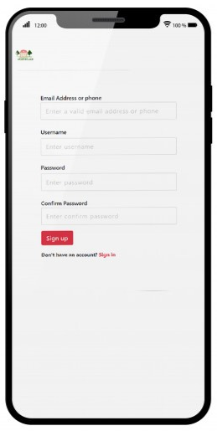 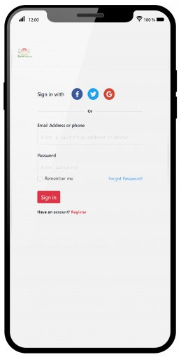

Figure . Sign in with EstateLux App in Iphone 12

|  |  |
| --- | --- |
| ***Advantages*** | ***Disadvantages*** |
| GUI is user-friendly, support language: Vietnamese. | Available IOS and Android |
| Freeware, public on Google Play and Appstore | Need internet to take notification |
| Handy, simple, easy to use anytime, anywhere |  |

* 1. Web application

This software is published publicly on the Internet and it is free software. It covers the business aspects of a real estate company and based on the needs of the current real estate market such as: helping the business to promote its business, introducing project proposals to guests. branding, promoting the brand, reaching customers anytime, anywhere, is an information channel that helps you easily call for investment, moreover this software can help buyers easily find a house or share.

This software only supports remote access and all data is stored on the server. The server uses Database-as-a-Service (MySQL), bringing many benefits such as Security, High availability, and less

configuration. It is a good choice and an example we consider using MySQL.

|  |  |
| --- | --- |
| ***Advantages*** | ***Disadvantages*** |
| GUI is user-friendly, support language: Vietnamese | Only support remote access (Web), (Mobile App) no support for offline use (Desktop apps) |
| Website’s staff will on the website 24/7 | Only support via hotline, facebook not via zalo, etc… |
| As long as the internet is available, it can be accessed at anytime. | Low security, easy to attack by hackers |



Figure .Login interface of EstateLux

* 1. Backend system

Backend system is made based on Spring MVC. Using hibernate, JPA connect to MySQL database, support security.

Frontend system is made base MVC and use another library and with HTML, CSS, Javascript.

## Business Opportunity

In 2020, two outbreaks of COVID-19 broke out in our country, causing serious impacts on the economy, and the domestic real estate market is no exception. Challenges posed by the COVID-19 pandemic as well as a slowdown in economic growth caused demand decline, directly affecting Vietnam's real estate market.

This takes place in markets such as Ho Chi Minh City and Hanoi with great demand for the housing segment, especially the affordable and mid-end apartment segments ..., greatly affecting the overall market situation. It is an imbalance in real estate products supplied in the market with a large but unmet housing demand for low, middle and low income earners. It is also the inadequacy of the price level of real estate products when they continue to be anchored at high levels despite the market's difficulties; This is especially noticeable in 2020 when the COVID-19 epidemic continues to have complicated developments.

Recorded in 2020 by the Vietnam Real Estate Brokerage Association shows that by the end of the third quarter, nearly 80,000 products were offered for sale on the market, of which 70% of inventories were from previous years. New supply in the first 3 quarters of 2020 only reached over 20,000 new products for the first time on the market. In particular, the apartment product - mid-end segment accounts for the largest proportion of about 75%, the affordable segment (the whole country combined) is about 10%, the high-end segment accounts for 14% of the supply to the market in in 2019. In the transaction, for the mid-end product line, it is still the condominium product line with the price of 25-35 million VND / m2 with the highest transaction, accounting for 75%. High-end products with high prices, over 50 million / m2, especially in Hanoi, have the lowest transaction volume, only 5%. Undeniably in the 21st century, with the development of science and technology, the real estate market has become extremely convenient and easily accessible.

The market is increasingly rich and diverse with many types of rental models, or sale of apartments, apartments, land. Their common point is that with the seller - buyer model, customers can easily find out full information about the product as well as obtain information of the seller. A customer can buy an apartment and then lease it to someone else, or a student can rent an apartment and look for other people to live with to reduce their rent.

Therefore, the management system as well as the consolidation of the real estate market also becomes extremely complex. That is the reason that we have created Real Estate Website Management with the desire to create a website that accurately synthesizes real estate projects and attracts customers.

Our team believes our system will have an upper hand over others, and it will make a difference that can attract customers:

- The easy-to-use interface can be suitable for many types of customers, with many features and utilities.

- Online working system. There will always be a website manager operating 24/7 ready to answer questions or handle customer requests

- The system will always update information on real estate projects quickly and accurately. Smartphone application development: This is very convenient and very effective when you can quickly check information, when receiving a new notification will immediately show up on your phone. avoid missing information. - Besides, we have a team of collaborators everywhere to help check and confirm information about real estate projects announced on the Website.

## Software Product Vision

Real Estate Website Management was built up to be a website specializing in introducing real estate projects that are being delivered for sale or lease to customers.

Our target customers here are included sellers and buyers. The sellers are businesses, companies or individuals wishing to sell or sublease their real estate such as: apartments, apartments, villas, houses or land. Buyers are those who want to find out information about real estate projects to buy or rent.

Here Real Estate Website Management will summarize available real estate projects to include details about the project and information of the seller. Buyers can find out and review the information on the website and can contact us to answer questions or handle requests based on customers' wishes. Besides, the buyer can contact the seller directly to find out more details as well as discuss the purchase - sale contract.

The seller is required to register an account with his personal information before he wants to post information about the real estate project he wants to lease-sell. The seller can update the project information as well as communicate directly with the buyer.

## Project Scope & Limitations.

6.1 Major Features

* Mobile application:
  + Role: Customer
    - Allows users to view and change personal information
    - Allows users to monitor device information such as: property price, area, location, photos, bedrooms , phone , …
    - Sort by area , price and the purpose (rent or buy )
    - Contact with EstateLux via realtime message (24/7)
    - Send a request to the host for the host to contact again via email or phone
    - Search estate
    - Change to the phone call app to call directly to the host
  + Role: Host
    - Allows host to manage list estate information that belongs to your data
    - Allows Store to add new estate and information of estate
    - Allows host to view and change personal information
    - Match contact between customer and host via email or phone
* Web application
  + Role: Host

# Software Requirement Specification

## Overall Description

* 1. Product Overvie

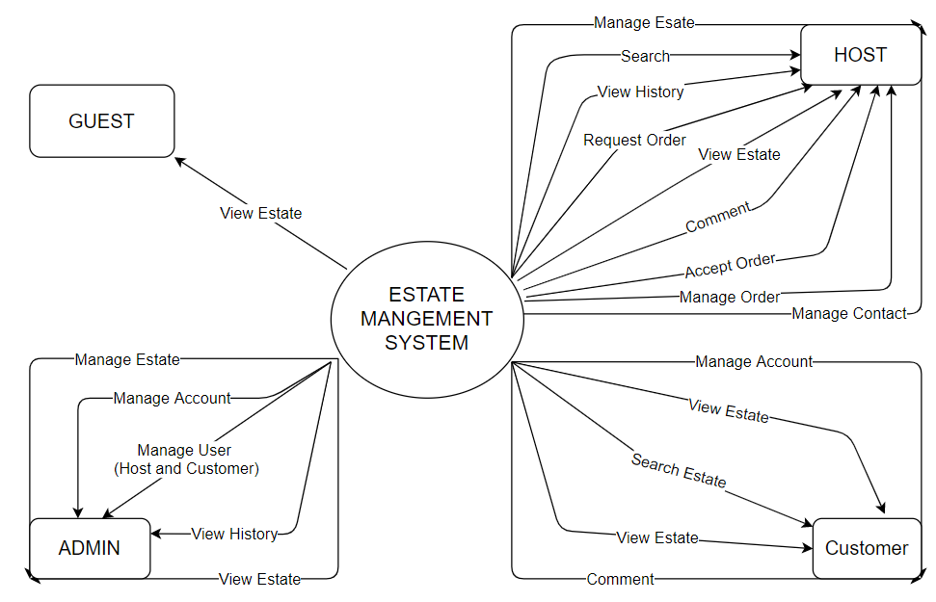

Nowadays, the transaction between customers and broker is very complicated because there are some risks about it. First, brokers maybe provide to the customer the real estate projects that incomplete legal. Second, the transactions have fake documents, scammers and so on… Finally, the transaction can not be finished because the brokers can not know the owner of this property. All of the above can cause anxiety to the customers so they have to check every information about the real estate project carefully before they can decide to buy it. So our application will solve the problem that matters the customers and the brokers, we will have all the information you need to make the transaction with the broker and brokers do not have to worry about all the problems the can make harm to the transaction. Context diagrams show the connections, communication of the real estate lux system for external objects. The system will have all of the information of the real estate, co-owner and legal documents that can help customers and brokers for a favorable transaction.

* 1. Business Rules

|  |  |
| --- | --- |
| **No** | **Description** |
| BR-01 | Real estate projects that owners post on the system must be full of legal documents, owner’s phone number, address, condition. |
| BR-02 | When the customers want to have a transaction, customers have to send all of legal information like phone number, identity card number, and other legal documents about the customers to the broker so they can prevent scammers. |
| BR-03 | When both sides agree about the transaction, brokers will create a contract about real estate transaction to the customers. |
| BR-04 | After an online discussion between customer and broker, they will have a direct meeting to come to conclusion. |
| BR-05 | Broker can have 1% to 2% of the transaction fee after the transaction complete. |
| BR-06 | Real estate projects that are underrated will be remove from the system. |
| BR-07 | Agree to the terms of service and privacy policy |
| BR-08 | One email, phone number can only register a single account |
| BR-09 | Appropriate language, do not use inappropriate language. |
| BR-10 | Respect customer privacy. |
| BR-11 | Passwords require at least 8 characters including letters and numbers, excluding special characters  If you already have a document, the new password must be different from the old one |
| BR-12 | Cancellation is only permitted when both customers and brokers unaccepted the request. |
| BR-13 | Customers can not change decision after the transaction is completed. |

## User Requirements

### Use-case Diagram

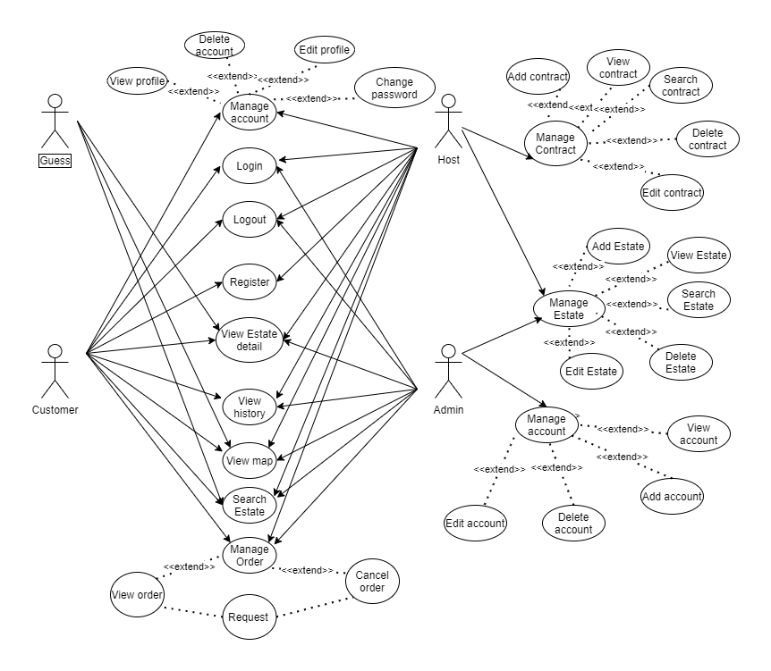

Figure 2.1: Use-case diagram

### Use-case list

|  |  |  |  |
| --- | --- | --- | --- |
| **ID** | **Actor** | **Function** | **Glossary** |
| UC-01 | Guest | View Estate detail | Guest can view detail information about the Estate |
| UC-02 | Guest | Search Estate | Guest can search Estate by filter |
| UC-03 | Guest | View map | Guest can view the Estate in the real-map |
| UC-04 | Customer | Register account | Customer can register account |
| UC-05 | Customer | Login | Customer login into system |
| UC-06 | Customer | Logout | Customer logout system |
| UC-07 | Customer | Search Estate | Customer can search Estate by filter |
| UC- 08 | Customer | View Estate detail | Customer can view detail information about the Estate |
| UC-09 | Customer | View profile | Customer view his (or her) profile |
| UC-10 | Customer | Edit profile | Customer edit his (or her) profile |
| UC-11 | Customer | Delete account | Customer delete his or her account |
| UC-12 | Customer | Change password | Customer change password |
| UC-13 | Customer | Request order | Customer request order |
| UC-14 | Customer | View order | Customer view order |
| UC-15 | Customer | Cancel order | Customer cancel order |
| UC-16 | Customer | View history | Customer can view their order history |
| UC-17 | Customer | View map | Customer can view the Estate in the real-map |
| UC-18 | Customer | Comment | Customer can comment for feedback the completed order about the Estate |
| UC-19 | Host | Register account | Host can register account |
| UC- 20 | Host | Login | Host login into system |
| UC-21 | Host | Logout | Host logout system |
| UC-22 | Host | Search Estate | Host search Estate by filter |
| UC-23 | Host | View history | Host can view their order history |
| UC-24 | Host | View profile | Host view his (or her) profile |
| UC-25 | Host | Edit profile | Host edit his (or her) profile |
| UC-26 | Host | Delete account | Host delete his or her account |
| UC-27 | Host | Change password | Customer change password |
| UC-28 | Host | Add a contract | Host can add a contract when accept a customer’s order |
| UC-29 | Host | Cancel a contract | Host can cancel a contract |
| UC-30 | Host | View contract | Host can view all of their contract |
| UC-31 | Host | Search contract | Host can search contract |
| UC-32 | Host | Edit contract | Host can edit contract |
| UC-33 | Host | Add Estate | Host can add a new estate with detail information |
| UC-34 | Host | Edit Estate | Host can edit detail information about the Estate |
| UC-35 | Host | Delete Estate | Host can delete a Estate |
| UC-36 | Host | View Estate | Host can view a Estate |
| UC37 | Host | Search Estate | Host can search Estate by filter |
| UC-38 | Host | View map | Host can view the Estate in the real-map |
| UC-39 | Admin | Login | Admin login into system |
| UC-40 | Admin | Logout | Admin logout system |
| UC-41 | Admin | View history | Admin can view all order history |
| UC-42 | Admin | View Estate detail | Admin can view detail information about the Estate |
| UC-43 | Admin | View profile | Admin can view profile of Host and Customer |
| UC-44 | Admin | Edit account | Admin can edit profile of customers and jobber |
| UC-45 | Admin | Delete account | Admin can delete account customers and jobber |
| UC-46 | Admin | Add account | Admin can add account |
| UC-47 | Admin | Request order | Admin can request order |
| UC-48 | Admin | Accept order | Admin can accept order |
| UC-49 | Admin | Cancel order | Admin can cancel order |
| UC-50 | Admin | View order | Admin can view order information |
| UC-51 | Admin | Add Estate | Admin can add a new estate with detail information |
| UC-52 | Admin | Edit Estate | Admin can edit detail information about the Estate |
| UC-53 | Admin | Delete car | Admin can delete a Estate |
| UC-54 | Admin | View Estate | Admin can view a Estate |
| UC-55 | Admin | Search Estate | Admin can search Estate by filter |

* + 1. ***Guest***
       1. ***Register account***

|  |  |  |  |
| --- | --- | --- | --- |
| **Use Case ID** | UC-01 | | |
| **Use Case Name** | Register account | | |
| **Creator** | QuangHV | **Date Created** | 23/02/2021 |
| **Version** | 1.0 | **Last Updated** | 23/02/2021 |
| **Actor** | Guest | **Secondary Actors** | N/A |
| **Description** | Create a new account | | |
| **Pre-conditions** | * Guest can access the system * Guest is currently not Loged in. | | |
| **Post-conditions** | * The account is added to the system. * Guest is automatically Loged into the system. * Guest is redirected to Login page. | | |
| **Normal Flow** | 1. From the homepage, the Guest clicks on button "Sign in” 2. The system will load the Login and Register page. 3. User fills information into the required form. 4. User clicks "Sign up". | | |
| **Alternative Flows** | N/A | | |
| **Exceptions** | *EXC1: At step 3 of normal flow, Guest leaves fields blank, then proceeds to step 4.*  The system displays the error message "Please fill out this field”. Guest is not registered  *EXC2: At step 3 of normal flow, Guest enters a valid username that already exists in the system.*  The system displays the error message " Username already exists!". Guest is not registered.  *EXC3: At step 3 of normal flow, Guest enters a valid phone number that already exists in the system.*  The system displays the error message " Phone number already exists!". Guest is not registered.  *EXC4: At step 3 of normal flow, Guest enters a valid email that already exists in the system.*  The system displays the error message " Email address already exists!". Guest is not registered.  *EXC5: At step 3 of normal flow, Guest enters re-password that do not match*  The system displays the error message “The password does not match!". Guest is not registered. | | |
| **Priority** | High | | |
| **Frequency of Use** | High | | |
| **Business Rules** | N/A | | |
| **Other Information** | N/A | | |

* + - 1. ***Search Estate***

|  |  |  |  |
| --- | --- | --- | --- |
| **Use Case ID** | UC-02 | | |
| **Use Case Name** | Search Estate | | |
| **Creator** | QuangHV | **Date Created** | 23/02/2021 |
| **Version** | 1.0 | **Last Updated** | 23/02/2021 |
| **Actor** | Guest | **Secondary Actors** | N/A |
| **Description** | User requests search for vehicles | | |
| **Pre-conditions** | * Guest can access the system * Guest is currently not Loged in. | | |
| **Post-conditions** | * System redirect to list car page | | |
| **Normal Flow** | 1. From the app. 2. The system proposes the general attributes of the vehicle 3. Users based on available attributes to select or make other requirements 4. The person who chooses to search 5. The system recognizes and filters out models in accordance with the requirements that the user has chosen to search 6. The system exports a list of filtered cars | | |
| **Alternative Flows** | 4.1 No returns  The system could not find any vehicles that matched the requirements  The system informs the user that the model is not found in accordance with the requirements  Return to step 1 of normal flow  4.2 Rental vehicles  If the car has been rented, the status notice "rented"  4.3 Don't select properties  Users who do not make separate requirements for vehicles need to search  The system returns a list of all vehicles currently existing on the system | | |
| **Exceptions** | N/A | | |
| **Priority** | High | | |
| **Frequency of Use** | High | | |
| **Business Rules** | N/A | | |
| **Other Information** | When the system does not find the required model information, the system will suggest that some models have one of the same characteristics | | |

* + - 1. ***View estate detail***

|  |  |  |  |
| --- | --- | --- | --- |
| **Use Case ID** | UC-03 | | |
| **Use Case Name** | View Estate detail | | |
| **Creator** | QuangHv | **Date Created** | 23/02/2021 |
| **Version** | 1.0 | **Last Updated** | 23/02/2021 |
| **Actor** | Guest | **Secondary Actors** | N/A |
| **Description** | The user asks to see the details of the estate | | |
| **Pre-conditions** | * Guest can access the system * Guest is currently not Loged in. | | |
| **Post-conditions** | * The system returns details of the selected model | | |
| **Normal Flow** | 1. From the app. 2. The system loads list car 3. Guest choose the model of the car 4. The system searches for information according to the requirements selected in the database 5. The system returns details of the vehicle posted by jobber | | |
| **Alternative Flows** | N/A | | |
| **Exceptions** | *N/A* | | |
| **Priority** | Medium | | |
| **Frequency of Use** | High | | |
| **Business Rules** | N/A | | |
| **Other Information** | N/A | | |

* + 1. ***Host***

***2.2.3.1 Register account***

|  |  |  |  |
| --- | --- | --- | --- |
| **Use Case ID** | UC-19 | | |
| **Use Case Name** | Register account | | |
| **Creator** | TruongHD | **Date Created** | 2021/2/23 |
| **Version** | 1.0 | **Last Updated** | 2021/2/21 |
| **Actor** | Host | | |
| **Description** | Host access the system and sign up for an account | | |
| **Pre-conditions** | None | | |
| **Post-conditions** | POST-1. Notifications to host who have successfully registered an account  POST-2. The data in the application is stored (initially) in the database | | |
| **Normal Flow** | 1. Host requests account registration  2. The system displays the application for create an account  3. Host fill out the information in the application form  4. The system checks data and notices that it has successfully registered  5. Login page display system | | |
| **Alternative Flows** | Sign up for multiple accounts  Host registering for another account  Return to step 1 of normal flow | | |
| **Exceptions** | 1.0. E1 Duplicate or incomplete information  1. The system informs the Host that the information already exists  2a. If the Host re-enters the information, perform the next step of normal flow  2b. If the Host cancels the account subscription, then the system terminates use case. | | |
| **Priority** | Medium | | |
| **Frequency of Use** | Low | | |
| **Business Rules** | BR-09, BR-10, BR-13 | | |
| **Other Information** | If during registration, network loss or timeout, the system automatically returns to the registration page and saves all the jobber information filled out. | | |

***2.2.3.2 Login***

|  |  |  |  |
| --- | --- | --- | --- |
| **Use Case ID** | UC-20 | | |
| **Use Case Name** | Login | | |
| **Creator** | TruongHD | **Date Created** | 2021/2/23 |
| **Version** | 1.0 | **Last Updated** | 2021/2/23 |
| **Actor** | Host | | |
| **Description** | Host login to account | | |
| **Pre-conditions** | Host must have an account | | |
| **Post-conditions** | POST-1. Notifications to host who have successfully logged on to the account  POST-2. The system allows access to the features that the account allows | | |
| **Normal Flow** | 1. Host requests account login  2. The system displays the account login application  3. Host fills out the information in the login form  4. Data checking system and successfully logged in notifications  5. Return to the page before logging into the account | | |
| **Alternative Flows** | 2.1 Sign in to multiple accounts  Host log in to different accounts in different windows, different browsers on the same device  When the Host reloads the page, the system automatically synchronizes to the last logged-in recorded account  2.2 Forgot password  Host forgets account password  Returns the change password page | | |
| **Exceptions** | 2.0. E1 Incomplete or inaccurate information  1. The system notified the jobber  2a. If the jobber re-enters the information, perform the next step of normal flow  2b. If the Host cancels the login, then the system terminates use case. | | |
| **Priority** | Medium | | |
| **Frequency of Use** | High | | |
| **Business Rules** | None | | |
| **Other Information** | If during the login process, network loss, or timeout expires, the system automatically returns to the sign-in page and saves all the information the Host has filled out  Expect high frequency of executing this use case within first 2 weeks after system is released. | | |

**2.2.3.3 Logout**

|  |  |  |  |
| --- | --- | --- | --- |
| **Use Case ID** | UC-21 | | |
| **Use Case Name** | Logout | | |
| **Creator** | TruongHD | **Date Created** | 2021/2/23 |
| **Version** | 1.0 | **Last Updated** | 2021/2/23 |
| **Actor** | Host | | |
| **Description** | Host signed out of the account | | |
| **Pre-conditions** | Host is logged into system | | |
| **Post-conditions** | Host is logged into system. | | |
| **Normal Flow** | 1. Host requests to log out of account  2. Home return system | | |
| **Alternative Flows** | None | | |
| **Exceptions** | None | | |
| **Priority** | Medium | | |
| **Frequency of Use** | High | | |
| **Business Rules** | None | | |
| **Other Information** | None | | |

***2.2.3.4 Search car***

|  |  |  |  |
| --- | --- | --- | --- |
| **Use Case ID** | UC-22 | | |
| **Use Case Name** | Search Estate | | |
| **Creator** | TruongHD | **Date Created** | 2021/2/23 |
| **Version** | 1.0 | **Last Updated** | 2021/2/23 |
| **Actor** | Host | | |
| **Description** | Host access the system and choose the properties of the Estate to find to suit the needs of use and purpose. The system filters and returns models that are suitable for search conditions. | | |
| **Pre-conditions** | None | | |
| **Post-conditions** | The system returns a list of models that match the requirements that the Host has chosen | | |
| **Normal Flow** | 1. The system proposes the general attributes of the Estate  2. Host based on available attributes to select or make other requirements  3. Host can search by advanced search  4. The system recognizes and filters out models in accordance with the requirements that the Host has chosen to search  5. The system exports a list of filtered Estate | | |
| **Alternative Flows** | *No returns  The system could not find any Estate that matched the requirements  The system informs the Host that the model is not found in accordance with the requirements  Return to step 1 of normal flow  *Estate status  If the Estate has been rented, the status notice "rented" or sale is “has been sale”, else Customer can make a contract with Host  * Don't select properties  Host who do not make separate requirements for Estate need to search  The system returns a list of all Estate currently existing on the system | | |
| **Exceptions** | None | | |
| **Priority** | High | | |
| **Frequency of Use** | High | | |
| **Business Rules** | None | | |
| **Other Information** | When the system does not find the required model information, the system will display a message “Not found” and suggest that some models have one of the same characteristics. | | |

***2.2.3.5 View history***

|  |  |  |  |
| --- | --- | --- | --- |
| **Use Case ID** | UC-23 | | |
| **Use Case Name** | View history | | |
| **Creator** | TruongHD | **Date Created** | 2021/2/23 |
| **Version** | 1.0 | **Last Updated** | 2021/2/23 |
| **Actor** | Host | | |
| **Description** | Host access the system to view history of order | | |
| **Pre-conditions** | Account login | | |
| **Post-conditions** | None | | |
| **Normal Flow** | 1.Host logged on successfully  2.Host choose history | | |
| **Alternative Flows** | The system will display all of order from the Customer. If the order was accepted, it will be change to contract. | | |
| **Exceptions** | None | | |
| **Priority** | Low | | |
| **Frequency of Use** | Low | | |
| **Business Rules** | BR-02, BR-03, BR-05,BR-08,BR-16 | | |
| **Other Information** | If Host don’t have any Order, the system will display a message “ You haven’t have any order yet!” | | |

**2.2.3.7 View profile**

|  |  |  |  |
| --- | --- | --- | --- |
| **Use Case ID** | UC-24 | | |
| **Use Case Name** | View profile | | |
| **Creator** | TruongHD | **Date Created** | 2021/2/23 |
| **Version** | 1.0 | **Last Updated** | 2021/2/23 |
| **Actor** | Host | | |
| **Description** | Host request review the personal information of the account are displayed to others (account name...) as well as security information (password...) | | |
| **Pre-conditions** | Host is logged into system. | | |
| **Post-conditions** | The system returns the page containing the details of the account | | |
| **Normal Flow** | 1. Host requests access to account information  2. The system searches for information about the requested account stored in the database  3. System returns page containing information about account | | |
| **Alternative Flows** | None | | |
| **Exceptions** | None | | |
| **Priority** | Medium | | |
| **Frequency of Use** | Medium | | |
| **Business Rules** | None | | |
| **Other Information** | The system will issue a notice requesting updates when important information is not fully filled out | | |

**2.2.3.8 Edit profile**

|  |  |  |  |
| --- | --- | --- | --- |
| **Use Case ID** | UC-25 | | |
| **Use Case Name** | Edit profile | | |
| **Creator** | TruongHD | **Date Created** | 2021/2/23 |
| **Version** | 1.0 | **Last Updated** | 2021/2/23 |
| **Actor** | Host | | |
| **Description** | Host requests to edit the personal information of the account | | |
| **Pre-conditions** | Host is logged into system. | | |
| **Post-conditions** | 1. The system stores the information after editing  2. The system updates the edited information into the database  3. The system notified the Host that "the information has been updated successfully" | | |
| **Normal Flow** | 1. Host requests correction of account information  2. System returns page containing editable information  3. Host edit information  4. Host choose to save information after use  5. The system updates the information in the database  6. System notices "information has been successfully updated" | | |
| **Alternative Flows** | Host delete information that is required to be updated  Returns a message asking to fill and go back to step 3 of normal flow | | |
| **Exceptions** | * Host enters data that is not true to the format used for the data type  1. The system notified host to follow the format  2a. If the host re-enters the information, perform the next step of normal flow  2b. If the host cancels the modification, then the system terminates use case. | | |
| **Priority** | Medium | | |
| **Frequency of Use** | Low | | |
| **Business Rules** | BR-10, BR - 11 | | |
| **Other Information** | Do not allow Host to edit passwords when editing profiles | | |

**2.2.3.9 Delete profile**

|  |  |  |  |
| --- | --- | --- | --- |
| **Use Case ID** | UC-26 | | |
| **Use Case Name** | Delete account | | |
| **Creator** | TruongHD | **Date Created** | 2021/2/23 |
| **Version** | 1.0 | **Last Updated** | 2021/2/23 |
| **Actor** | Host | | |
| **Description** | The Host wants to delete the account | | |
| **Pre-conditions** | Host is logged into system. | | |
| **Post-conditions** | 1. System deletes Host’s accounts from databases  2. The system returns the home page | | |
| **Normal Flow** | 1. Host requests permanent account deletion  2. System returns information page on account deletion issues  3. The Host confirmation system is sure you want to delete the account  4. Host confirmation  5. The system requires entering a password to perform the account deletion process  6. Host enters password and saves changes  7. The system updates the information in the database  8. Home return system | | |
| **Alternative Flows** | * Cancel account deletion request  Host requests cancellation of account deletion  System cancels request and returns to page before requesting account deletion | | |
| **Exceptions** | None | | |
| **Priority** | Low | | |
| **Frequency of Use** | Medium | | |
| **Business Rules** | BR-09 | | |
| **Other Information** | When the Host confirmation, he (she) must enter password again, if it’s correct the delete will be cancel | | |

**2.2.3.10 Change password**

|  |  |  |  |
| --- | --- | --- | --- |
| **Use Case ID** | UC-27 | | |
| **Use Case Name** | Change password | | |
| **Creator** | TruongHD | **Date Created** | 2021/2/23 |
| **Version** | 1.0 | **Last Updated** | 2021/2/23 |
| **Actor** | Host | | |
| **Description** | The Host wants to change password of the account | | |
| **Pre-conditions** | Host is logged into system or forget your password when logging in | | |
| **Post-conditions** | 1. Password checking and storage system changed  2. The system updates data into the database  3. The system returns the message "Successfully changed password" | | |
| **Normal Flow** | 1. Host requests account change  2. The system exports to a page that allows password to be changed  3. The Host enters the information and saves the change  4. The system updates password information in the database  5. System notices "Passwords have been successfully updated" | | |
| **Alternative Flows** | *Forgot password  When logging into the account, the Host selects "Forgot password"  The system asks to choose how to enter a new password (email, message (phone number) that has been stored in the database)  The system will send back the new login password through the method that the Host has selected  Go back to step 2 of normal flow  *Password not available  The Host entering the new password does not meet the system requirements  System notifications and return to step 3 of normal flow | | |
| **Exceptions** | None | | |
| **Priority** | Medium | | |
| **Frequency of Use** | Medium | | |
| **Business Rules** | BR-13 | | |
| **Other Information** | If during a password change, loss of network, or system failure, the system will not make a password change and return to the page before a request to change the password information | | |

***2.2.4 Admin***

**2.2.4.1 Accept order**

|  |  |  |  |
| --- | --- | --- | --- |
| **Use Case ID** | UC-28 | | |
| **Use Case Name** | Add a contract | | |
| **Creator** | TruongHD | **Date Created** | 2021/2/23 |
| **Version** | 1.0 | **Last Updated** | 2021/2/23 |
| **Actor** | Host | | |
| **Description** | Host accept order from user and it will be change to a contract | | |
| **Pre-conditions** | Host access the system.  Host accept the order from Customer. | | |
| **Post-conditions** | The system receives the request of the Customer  Host see the order from user. | | |
| **Normal Flow** | 1. The system sends notifications to Host  2. The jobber resends the request (accept)  3. System for finding information about petitions and changing status  4. The system sends back notifications to the Customer | | |
| **Alternative Flows** | None | | |
| **Exceptions** | None | | |
| **Priority** | High | | |
| **Frequency of Use** | High | | |
| **Business Rules** | None | | |
| **Other Information** | None | | |

**2.2.4.2 Cancel order**

|  |  |  |  |
| --- | --- | --- | --- |
| **Use Case ID** | UC-29 | | |
| **Use Case Name** | Cancel a contract | | |
| **Creator** | TruongHD | **Date Created** | 2021/2/23 |
| **Version** | 1.0 | **Last Updated** | 2021/2/23 |
| **Actor** | Host | | |
| **Description** | Host cancel order from Customer | | |
| **Pre-conditions** | Host access the system.  Host deny the order from Customer. | | |
| **Post-conditions** | The system receives the request of the Customer  Host see the order from user. | | |
| **Normal Flow** | 1. The system sends notifications to Host  2. The jobber resends the request (deny)  3. System for finding information about petitions and changing status  4. The system sends back notifications to the renter | | |
| **Alternative Flows** | None | | |
| **Exceptions** | None | | |
| **Priority** | High | | |
| **Frequency of Use** | High | | |
| **Business Rules** | None | | |
| **Other Information** | None | | |

**2.2.4.3 View order**

|  |  |  |  |
| --- | --- | --- | --- |
| **Use Case ID** | UC-30 | | |
| **Use Case Name** | View contract | | |
| **Creator** | TruongHD | **Date Created** | 2021/2/23 |
| **Version** | 1.0 | **Last Updated** | 2021/2/23 |
| **Actor** | Host | | |
| **Description** | Host see information about the user's account | | |
| **Pre-conditions** | Host is logged into system | | |
| **Post-conditions** | The system returns the page containing the details of the account | | |
| **Normal Flow** | 1. Host requires access to account information  2. The system list all contract in the database (only about the Host account)  3. System returns page containing information about account | | |
| **Alternative Flows** | None | | |
| **Exceptions** | None | | |
| **Priority** | Medium | | |
| **Frequency of Use** | Medium | | |
| **Business Rules** | Respect customer privacy | | |
| **Other Information** | Admin can access to edit any information the database stores about the account | | |

**2.2.4.4 Search contract**

|  |  |  |  |
| --- | --- | --- | --- |
| **Use Case ID** | UC-31 | | |
| **Use Case Name** | Search contract | | |
| **Creator** | TruongHD | **Date Created** | 2021/2/23 |
| **Version** | 1.0 | **Last Updated** | 2021/2/23 |
| **Actor** | Host | | |
| **Description** | Host search all information about the contract that the Host want to find | | |
| **Pre-conditions** | Host is logged into system | | |
| **Post-conditions** | The system returns the page containing the details of the account | | |
| **Normal Flow** | 1. Host requires to find a list of contract in database  2. The system list all contract in the database (only about the Host account)  3. The Host search all information about the contract that the Host want to find  4. System returns page containing information about that contract | | |
| **Alternative Flows** | *No returns  The system could not find any contract that matched the requirements  The system informs the Host that the model is not found in accordance with the requirements  Return to step 1 of normal flow | | |
| **Exceptions** | None | | |
| **Priority** | High | | |
| **Frequency of Use** | High | | |
| **Business Rules** |  | | |
| **Other Information** | If don’t found the contract that Host want to find, the system will send a message “Don’t find!” | | |

**2.2.4.5 Edit car detail**

|  |  |  |  |
| --- | --- | --- | --- |
| **Use Case ID** | UC-32 | | |
| **Use Case Name** | Edit contract | | |
| **Creator** | TruongHD | **Date Created** | 2021/2/23 |
| **Version** | 1.0 | **Last Updated** | 2021/2/23 |
| **Actor** | Host | | |
| **Description** | Host can edit contract | | |
| **Pre-conditions** | Host is logged into system  The contract that Host want to edit must exist | | |
| **Post-conditions** | The system returns the page containing the details of the account | | |
| **Normal Flow** | 1. Host requires to edit contract.  2. Host choose the contract that want to edit  3. Host edit Contract  4. Host choose to save contract after edit  5. The system updates the information in the database  6. System notices “Contract has been successfully updated" | | |
| **Alternative Flows** | 1. The system updates the edited information into the database  2. The system notified the Host that "the information has been updated successfully" | | |
| **Exceptions** | * Host enters data that is not true to the format used for the data type  1. The system notified host to follow the format  2a. If the host re-enters the information, perform the next step of normal flow  2b. If the host cancels the modification, then the system terminates use case. | | |
| **Priority** | High | | |
| **Frequency of Use** | High | | |
| **Business Rules** |  | | |
| **Other Information** | None | | |

**2.2.4.6 Edit car detail**

|  |  |  |  |
| --- | --- | --- | --- |
| **Use Case ID** | UC-33 | | |
| **Use Case Name** | Add Estate | | |
| **Creator** | TruongHD | **Date Created** | 2020/2/23 |
| **Version** | 1.0 | **Last Updated** | 2020/2/23 |
| **Actor** | Host | | |
| **Description** | Host add a new Estate | | |
| **Pre-conditions** | Host is logged into system | | |
| **Post-conditions** | The system returns the page containing the details of the account | | |
| **Normal Flow** | 1. Host requires to add a new Estate  2. The system displays the application for add a new Estate  3. Host fill out the information in the adding form  4. The system checks data and notices that it has successfully added  5. System notices “Estate has been successfully added"  6. Back to the home page | | |
| **Alternative Flows** | 1. The system a new Estate information into the database  2. The system notified the Host that "the Estate has been added successfully" | | |
| **Exceptions** | * Host enters data that is not true to the format used for the data type  1. The system notified host to follow the format  2a. If the host re-enters the information, perform the next step of normal flow  2b. If the host cancels the modification, then the system terminates use case.  3. Host must enter all the information that in adding form | | |
| **Priority** | High | | |
| **Frequency of Use** | High | | |
| **Business Rules** |  | | |
| **Other Information** | None | | |

**2.2.4.6 Edit car detail**

|  |  |  |  |
| --- | --- | --- | --- |
| **Use Case ID** | UC-34 | | |
| **Use Case Name** | Edit Estate | | |
| **Creator** | TruongHD | **Date Created** | 2020/2/23 |
| **Version** | 1.0 | **Last Updated** | 2020/2/23 |
| **Actor** | Host | | |
| **Description** | Host edit Estate  The contract that Host want to edit must exist | | |
| **Pre-conditions** | Host is logged into system | | |
| **Post-conditions** | The system returns the page containing the details of the account | | |
| **Normal Flow** | 1. Host requires to edit Estate.  2. Host choose Estate that want to edit  3. Host edit Estate  4. Host choose to save Estate after edit  5. The system updates the Estate’s information in the database  6. System notices “Estate has been successfully updated" | | |
| **Alternative Flows** | 1. The system updates the edited Estate’s information into the database  2. The system notified the Host that "the Estate has been updated successfully" | | |
| **Exceptions** | * Host enters data that is not true to the format used for the data type  1. The system notified host to follow the format  2a. If the host re-enters the information, perform the next step of normal flow  2b. If the host cancels the modification, then the system terminates use case. | | |
| **Priority** | High | | |
| **Frequency of Use** | High | | |
| **Business Rules** |  | | |
| **Other Information** | None | | |

**2.2.4.6 Edit car detail**

|  |  |  |  |
| --- | --- | --- | --- |
| **Use Case ID** | UC-35 | | |
| **Use Case Name** | Delete Estate | | |
| **Creator** | TruongHD | **Date Created** | 2020/2/23 |
| **Version** | 1.0 | **Last Updated** | 2020/2/23 |
| **Actor** | Host | | |
| **Description** | The Host wants to delete Estate | | |
| **Pre-conditions** | Host is logged into system. | | |
| **Post-conditions** | 1. System deletes Estate’s information from databases  2. The system returns the home page | | |
| **Normal Flow** | 1. Host requests Estate deletion  2. System returns information page on account deletion issues  3. The Host confirmation system is sure you want to delete the Estate  4. Host confirmation  5. The system requires entering a password to perform the account deletion process  6. Host enters password and saves changes  7. The system delete Estate’s information in database  8. Home return system | | |
| **Alternative Flows** | * Cancel account deletion request  Host requests cancellation of account deletion  System cancels request and returns to page before requesting account deletion | | |
| **Exceptions** | None | | |
| **Priority** | Low | | |
| **Frequency of Use** | Medium | | |
| **Business Rules** | BR-09 | | |
| **Other Information** | When the Host confirmation, he (she) must enter password again, if it’s correct the deletion will be cancel | | |

|  |  |  |  |
| --- | --- | --- | --- |
| **Use Case ID** | UC-36 | | |
| **Use Case Name** | View Estate | | |
| **Creator** | TruongHD | **Date Created** | 2020/2/23 |
| **Version** | 1.0 | **Last Updated** | 2020/2/23 |
| **Actor** | Host | | |
| **Description** | Host view Estate’s information | | |
| **Pre-conditions** | Host is logged into system | | |
| **Post-conditions** | The system returns the page containing the details of the account | | |
| **Normal Flow** | 1. Host requires access to view Estate’s information  2. The system list all Estate in the database (Host can search to find exactly kind that Host want to find)  3. System returns page containing information about account | | |
| **Alternative Flows** | None | | |
| **Exceptions** | None | | |
| **Priority** | Medium | | |
| **Frequency of Use** | Medium | | |
| **Business Rules** | Respect customer privacy | | |
| **Other Information** | Admin can access to edit any information the database stores about the account | | |

|  |  |  |  |
| --- | --- | --- | --- |
| **Use Case ID** | UC-37 | | |
| **Use Case Name** | Search Estate | | |
| **Creator** | TruongHD | **Date Created** | 2020/2/23 |
| **Version** | 1.0 | **Last Updated** | 2020/2/23 |
| **Actor** | Host | | |
| **Description** | Host access the system and choose the properties of the Estate to find to suit the needs of use and purpose. The system filters and returns models that are suitable for search conditions. | | |
| **Pre-conditions** | None | | |
| **Post-conditions** | The system returns a list of models that match the requirements that the Host has chosen | | |
| **Normal Flow** | 1. The system proposes the general attributes of the Estate  2. Host based on available attributes to select or make other requirements  3. Host can search by advanced search  4. The system recognizes and filters out models in accordance with the requirements that the Host has chosen to search  5. The system exports a list of filtered Estate | | |
| **Alternative Flows** | *No returns  The system could not find any Estate that matched the requirements  The system informs the Host that the model is not found in accordance with the requirements  Return to step 1 of normal flow  *Estate status  If the Estate has been rented, the status notice "rented" or sale is “has been sale”, else Customer can make a contract with Host  * Don't select properties  Host who do not make separate requirements for Estate need to search  The system returns a list of all Estate currently existing on the system | | |
| **Exceptions** | None | | |
| **Priority** | High | | |
| **Frequency of Use** | High | | |
| **Business Rules** |  | | |
| **Other Information** | When the system does not find the required model information, the system will display a message “Not found” and suggest that some models have one of the same characteristics. | | |

|  |  |  |  |
| --- | --- | --- | --- |
| **Use Case ID** | UC-38 | | |
| **Use Case Name** | View map | | |
| **Creator** | TruongHD | **Date Created** | 2020/2/23 |
| **Version** | 1.0 | **Last Updated** | 2020/2/23 |
| **Actor** | Host | | |
| **Description** | Host can view the Estate in the real-map | | |
| **Pre-conditions** | Host is logged into system | | |
| **Post-conditions** | The system returns the page containing the details of the account | | |
| **Normal Flow** | 1. Host requires to view Estate in a real-map  2 Mapping | | |
| **Alternative Flows** |  | | |
| **Exceptions** |  | | |
| **Priority** | High | | |
| **Frequency of Use** | High | | |
| **Business Rules** |  | | |
| **Other Information** | None | | |

* + 1. ***Customer***
       1. ***Register account***

|  |  |  |  |
| --- | --- | --- | --- |
| **Use Case ID** | UC-04 | | |
| **Use Case Name** | Register account | | |
| **Creator** | LongNT | **Date Created** | 23/02/2021 |
| **Version** | 1.0 | **Last Updated** | 23/02/2021 |
| **Actor** | Customer | **Secondary Actors** | N/A |
| **Description** | Create a new account | | |
| **Pre-conditions** | * Customer can access the system * Customer is currently not Loged in. | | |
| **Post-conditions** | * The account is added to the system. * Customer is automatically Loged into the system. * Customer is redirected to Login page. | | |
| **Normal Flow** | 1. From the homepage, the Guest clicks on button "Sign in” 2. The system will load the Login and Register page. 3. User fills information into the required form. 4. User clicks "Sign up". | | |
| **Alternative Flows** | N/A | | |
| **Exceptions** | *EXC1: At step 3 of normal flow, Customer leaves fields blank, then proceeds to step 4.*  The system displays the error message "Please fill out this field”. Customer is not registered  *EXC2: At step 3 of normal flow, Customer enters a valid username that already exists in the system.*  The system displays the error message " Username already exists!". Customer is not registered.  *EXC3: At step 3 of normal flow, Customer enters a valid phone number that already exists in the system.*  The system displays the error message " Phone number already exists!". Customer is not registered.  *EXC4: At step 3 of normal flow, Customer enters a valid email that already exists in the system.*  The system displays the error message " Email address already exists!". Customer is not registered.  *EXC5: At step 3 of normal flow, Customer enters re-password that do not match*  The system displays the error message “The password does not match!". Customer is not registered. | | |
| **Priority** | High | | |
| **Frequency of Use** | High | | |
| **Business Rules** | N/A | | |
| **Other Information** | N/A | | |

* + - 1. ***Login***

|  |  |  |  |
| --- | --- | --- | --- |
| **Use Case ID** | UC-05 | | |
| **Use Case Name** | Login to System | | |
| **Creator** | LongNT | **Date Created** | 23/02/2021 |
| **Version** | 1.0 | **Last Updated** | 23/02/2021 |
| **Actor** | Customer | **Secondary Actors** | N/A |
| **Description** | Login an account using username , phone and password | | |
| **Pre-conditions** | * Customer has already registered an account. * Customer is currently not Loged into the system. | | |
| **Post-conditions** | * Customer is Loged into the system. * Customer is redirected to Homepage. | | |
| **Normal Flow** | 1. From the homepage, the Customer clicks on button "Sign in” 2. The system loads the Login page. 3. Customer enters “username” or “phone” and “Password”. 4. Customer clicks “Sign in" button. 5. The system checks your input data. 6. If customer entered true, the system redirects customer to the Home page. | | |
| **Alternative Flows** | N/A | | |
| **Exceptions** | *EXC1: At step 3 of normal flow, Customer leaves fields blank, then proceeds to step 4.*  The system displays the error message "Please fill out this field". Customer is not Loged in.  *EXC2: At step 3 of normal flow,* Store *enters invalid Login credentials, then proceeds to step 4.*  The system displays the error message " Username ,Phone or Password is incorrect ". Customer is not Loged in. | | |
| **Priority** | High | | |
| **Frequency of Use** | High | | |
| **Business Rules** | N/A | | |
| **Other Information** | If during the login process, network loss, or timeout expires, the system automatically returns to the sign-in page and saves all the information the user has filled out  Expect high frequency of executing this use case within first 2 weeks after system is released. | | |

* + - 1. ***Logout***

|  |  |  |  |
| --- | --- | --- | --- |
| **Use Case ID** | UC-06 | | |
| **Use Case Name** | Logout | | |
| **Creator** | LongNT | **Date Created** | 23/02/2021 |
| **Version** | 1.0 | **Last Updated** | 23/02/2021 |
| **Actor** | Customer | **Secondary Actors** | N/A |
| **Description** | Logout of the account | | |
| **Pre-conditions** | * User accesses to the system. * User is currently Loged in. | | |
| **Post-conditions** | User is Loged out of the system. | | |
| **Normal Flow** | 1. In sidebar, customer clicks "Sign out". 2. The system will redirect customer to the Home page. | | |
| **Alternative Flows** | N/A | | |
| **Exceptions** | N/A. | | |
| **Priority** | Medium | | |
| **Frequency of Use** | Medium | | |
| **Business Rules** | N/A | | |
| **Other Information** | N/A | | |

* + - 1. **Search Estate**

|  |  |  |  |
| --- | --- | --- | --- |
| **Use Case ID** | UC-07 | | |
| **Use Case Name** | Search Estate | | |
| **Creator** | LongNT | **Date Created** | 23/02/2021 |
| **Version** | 1.0 | **Last Updated** | 23/02/2021 |
| **Actor** | Customer | **Secondary Actors** | N/A |
| **Description** | User requests search for real estate | | |
| **Pre-conditions** | * Guest can access the system * Guest is currently not Loged in. | | |
| **Post-conditions** | * System redirect to list estate | | |
| **Normal Flow** | 1. From the app. 2. The system proposes the general attributes of the estate 3. Users based on available attributes to select or make other requirements 4. The person who chooses to search 5. The system recognizes and filters out estate in accordance with the requirements that the user has chosen to search 6. The system exports a list of filtered estate | | |
| **Alternative Flows** | 4.1 No returns  The system could not find any estate that matched the requirements  The system informs the user that the estate is not found in accordance with the requirements  Return to step 1 of normal flow  4.2 Rental estate or Sold estate  If the estate has been rented, the status notice "rented" or “Sold”  4.3 Don't select properties  Users who do not make separate requirements for estate need to search  The system returns a list of all estate currently existing on the system | | |
| **Exceptions** | N/A. | | |
| **Priority** | High | | |
| **Frequency of Use** | High | | |
| **Business Rules** | N/A | | |
| **Other Information** | When the system does not find the required estate information, the system will suggest that some models have one of the same characteristics | | |

* + - 1. **View estate detail**

|  |  |  |  |
| --- | --- | --- | --- |
| **Use Case ID** | UC-08 | | |
| **Use Case Name** | View estate detail | | |
| **Creator** | LongNT | **Date Created** | 23/02/2021 |
| **Version** | 1.0 | **Last Updated** | 23/02/2021 |
| **Actor** | Customer | **Secondary Actors** | N/A |
| **Description** | The customer asks to see the details of the estate | | |
| **Pre-conditions** | * Customer can access the system * Customer is currently not Loged in. | | |
| **Post-conditions** | * The system returns details of the selected estate | | |
| **Normal Flow** | 1. From the app. 2. The system loads list estate 3. Customer choose the list of the estate 4. The system searches for information according to the requirements selected in the database 5. The system returns details of the estate posted by host | | |
| **Alternative Flows** | N/A | | |
| **Exceptions** | *N/A* | | |
| **Priority** | Medium | | |
| **Frequency of Use** | High | | |
| **Business Rules** | N/A | | |
| **Other Information** | N/A | | |

* + - 1. **View profile**

|  |  |  |  |
| --- | --- | --- | --- |
| **Use Case ID** | UC-09 | | |
| **Use Case Name** | View profile | | |
| **Creator** | LongNT | **Date Created** | 23/02/2021 |
| **Version** | 1.0 | **Last Updated** | 23/02/2021 |
| **Actor** | Customer | **Secondary Actors** | N/A |
| **Description** | User asks to see account details | | |
| **Pre-conditions** | * Customer is currently Loged into the system. | | |
| **Post-conditions** | * The system returns the page containing the details of the account | | |
| **Normal Flow** | 1. From the app. 2. User requests access to account information 3. The system searches for information about the requested account stored in the database 4. System returns page containing information about account | | |
| **Alternative Flows** | N/A | | |
| **Exceptions** | *N/A* | | |
| **Priority** | Medium | | |
| **Frequency of Use** | Medium | | |
| **Business Rules** | N/A | | |
| **Other Information** | N/A | | |

* + - 1. **Edit profile**

|  |  |  |  |
| --- | --- | --- | --- |
| **Use Case ID** | UC-10 | | |
| **Use Case Name** | Edit profile | | |
| **Creator** | LongNT | **Date Created** | 23/02/2021 |
| **Version** | 1.0 | **Last Updated** | 23/02/2021 |
| **Actor** | Customer | **Secondary Actors** | N/A |
| **Description** | User update personal information | | |
| **Pre-conditions** | Client is on the app mobile Client is Loging in  Client is on their profile page | | |
| **Post-conditions** | The User change their information successfully | | |
| **Normal Flow** | 1. In navbar, select the avatar and click “Profile” 2. The system will redirect User to the profile page. 3. User change their profile and click “Save” 4. The system will redirect User to the Profile page | | |
| **Alternative Flows** | N/A | | |
| **Exceptions** | *EXC1: At step 3 of normal flow, Guest leaves fields blank, then proceeds to step 4.*  The system displays the error message "Please fill out this field”. Guest is not registered  *EXC2: At step 3 of normal flow, Guest enters a valid phone number that already exists in the system.*  The system displays the error message " Phone number already exists!". Guest is not registered.  *EXC3: At step 3 of normal flow, Guest enters a valid email that already exists in the system.*  The system displays the error message " Email address already exists!". Guest is not registered.  *EXC4: At step 3 of normal flow, Guest enters re-password that do not match*  The system displays the error message “The password does not match!". Guest is not registered. | | |
| **Priority** | High | | |
| **Frequency of Use** | High | | |
| **Business Rules** | BR-8, BR - 9 | | |
| **Other Information** | N/A | | |

* + - 1. **Delete account**

|  |  |  |  |
| --- | --- | --- | --- |
| **Use Case ID** | UC-11 | | |
| **Use Case Name** | Delete account | | |
| **Creator** | AnNTD | **Date Created** | 23/02/2021 |
| **Version** | 1.0 | **Last Updated** | 23/02/2021 |
| **Actor** | Customer | **Secondary Actors** | N/A |
| **Description** | The user wants to delete the account | | |
| **Pre-conditions** | * User is logged into system. | | |
| **Post-conditions** | * System deletes user accounts from databases * The system returns the home page | | |
| **Normal Flow** | 1. User requests permanent account deletion  2. System returns information page on account deletion issues  3. The user confirmation system is sure you want to delete the account  4. User confirmation  5. The system requires entering a password to perform the account deletion process  6. User enters password and saves changes  7. The system updates the information in the database  8. Home return system | | |
| **Alternative Flows** | 1 Cancel account deletion request  User requests cancellation of account deletion  System cancels request and returns to page before requesting account deletion | | |
| **Exceptions** | *N/A* | | |
| **Priority** | Low | | |
| **Frequency of Use** | Medium | | |
| **Business Rules** | BR-07 | | |
| **Other Information** | If there is interruption in the process, the system will not perform this step | | |

* + - 1. **Change password**

|  |  |  |  |
| --- | --- | --- | --- |
| **Use Case ID** | UC-12 | | |
| **Use Case Name** | Change password | | |
| **Creator** | AnNTD | **Date Created** | 23/02/2021 |
| **Version** | 1.0 | **Last Updated** | 23/02/2021 |
| **Actor** | Customer | **Secondary Actors** | N/A |
| **Description** | The user wants to change the password for the account | | |
| **Pre-conditions** | * User is currently Logged into the system. | | |
| **Post-conditions** | * Password checking and storage system changed * The system updates data into the database * The system returns the message "Successfully changed password" | | |
| **Normal Flow** | 1. User requests account change 2. The system exports to a page that allows password to be changed 3. The user enters the information and saves the change 4. The system updates password information in the database 5. System notices "Passwords have been successfully updated" | | |
| **Alternative Flows** | N/A | | |
| **Exceptions** | *EXC1:*  Forgot password  When logging into the account, the user selects "Forgot password"  The system asks to choose how to enter a new password (email, message (phone number) that has been stored in the database)  The system will send back the new login password through the method that the user has selected  Go back to step 2 of normal flow  *EXC2:*  Password not available  The user entering the new password does not meet the system requirements  System notifications and return to step 3 of normal flow | | |
| **Priority** | Medium | | |
| **Frequency of Use** | Medium | | |
| **Business Rules** | BR-11 | | |
| **Other Information** | If during a password change, loss of network, or system failure, the system will not make a password change and return to the page before a request to change the password information | | |

* + - 1. **Request order**

|  |  |  |  |
| --- | --- | --- | --- |
| **Use Case ID** | UC-13 | | |
| **Use Case Name** | User requests order | | |
| **Creator** | AnNTD | **Date Created** | 23/02/2021 |
| **Version** | 1.0 | **Last Updated** | 23/02/2021 |
| **Actor** | Customer | **Secondary Actors** | N/A |
| **Description** | User requests order | | |
| **Pre-conditions** | * User is currently logged into the system. | | |
| **Post-conditions** | * The system saves the user's petition * System notified users of " Petition being processed" * The system sends the user's petition to the host | | |
| **Normal Flow** | 1. From the app. 2. Users request to adjust the real estate project 3. The system returns the page containing the information users need to provide to buy real estate project 4. The user fills out the information and sends the request 5. The system saves the user's petition 6. System notices "petitions are being processed" 7. The system sends a petition to the host | | |
| **Alternative Flows** | 1. Vacant information   Users do not fill in the required information  Returns a message asking to fill and go back to step 3 of normal flow | | |
| **Exceptions** | *EXC1: User leaves field blank, then proceeds to step 4.*  The system displays the error message "Please fill out this field". User is not order | | |
| **Priority** | High | | |
| **Frequency of Use** | High | | |
| **Business Rules** | BR-3, BR-4, BR-5, BR-7 | | |
| **Other Information** | N/A | | |

* + - 1. **View order**

|  |  |  |  |
| --- | --- | --- | --- |
| **Use Case ID** | UC-14 | | |
| **Use Case Name** | View order | | |
| **Creator** | AnNTD | **Date Created** | 23/02/2021 |
| **Version** | 1.0 | **Last Updated** | 23/02/2021 |
| **Actor** | Customer | **Secondary Actors** | N/A |
| **Description** | User requesting to view order | | |
| **Pre-conditions** | - User is logged into system.  - The user has submitted a request for real estate | | |
| **Post-conditions** | - The system searches for the request that the user has sent  - The system returns the page containing all the information filled out in the user's petition | | |
| **Normal Flow** | 1. From the app. 2. User requests to view order 3. The system searches for the request that the user has sent 4. The system returns the page containing the information in the user's petition | | |
| **Alternative Flows** | N/A | | |
| **Exceptions** | N/A | | |
| **Priority** | Medium | | |
| **Frequency of Use** | High | | |
| **Business Rules** | N/A | | |
| **Other Information** | N/A | | |

* + - 1. **Cancel order**

|  |  |  |  |
| --- | --- | --- | --- |
| **Use Case ID** | UC-15 | | |
| **Use Case Name** | Cancel order | | |
| **Creator** | AnNTD | **Date Created** | 23/02/2021 |
| **Version** | 1.0 | **Last Updated** | 23/02/2021 |
| **Actor** | Customer | **Secondary Actors** | N/A |
| **Description** | User requests cancellation of order real estate project. | | |
| **Pre-conditions** | * User is logged into system. * The user has submitted a request for a real estate project. | | |
| **Post-conditions** | * The system sends a user's request * System notices "Request accepted" | | |
| **Normal Flow** | 1. From the app. 2. User submits cancellation request 3. The system searches for the request that the user has sent 4. The system changes the status of the petition of the user who found the pharmacy 5. The system notified the user of the "accepted request" | | |
| **Alternative Flows** | 1. User's petition accepted by the host  The system sends cancellation requests to real estate project.   * If the jobber agrees, take the next step of normal flow * If the host disagrees, the system changes the status of the petition and returns the notice to the user "the request for cancellation of the application is not accepted" | | |
| **Exceptions** | *N/A* | | |
| **Priority** | Medium | | |
| **Frequency of Use** | Low | | |
| **Business Rules** | BR-12 | | |
| **Other Information** | N/A | | |

* + - 1. **View history**

|  |  |  |  |
| --- | --- | --- | --- |
| **Use Case ID** | UC-16 | | |
| **Use Case Name** | View history | | |
| **Creator** | AnNTD | **Date Created** | 23/02/2021 |
| **Version** | 1.0 | **Last Updated** | 23/02/2021 |
| **Actor** | Customer | **Secondary Actors** | N/A |
| **Description** | Users who want to review the history of order real estate project | | |
| **Pre-conditions** | * User is currently not logged into the system. | | |
| **Post-conditions** | * User is logged into the system. * User is redirected to Homepage. | | |
| **Normal Flow** | 1. In navbar, user click “History”. 2. The system will display the order history 3. User clicks on the order he wants to see to see details | | |
| **Alternative Flows** | N/A | | |
| **Exceptions** | *N/A* | | |
| **Priority** | Medium | | |
| **Frequency of Use** | High | | |
| **Business Rules** | N/A | | |
| **Other Information** | N/A | | |

* + - 1. **Comment**

|  |  |  |  |
| --- | --- | --- | --- |
| **Use Case ID** | UC-17 | | |
| **Use Case Name** | Comment | | |
| **Creator** | AnNTD | **Date Created** | 23/02/2021 |
| **Version** | 1.0 | **Last Updated** | 23/02/2021 |
| **Actor** | Customer | **Secondary Actors** | N/A |
| **Description** | Users want to rate/comment real estate after using it. | | |
| **Pre-conditions** | * User is currently logged into the system. * User has completed an order of real estate project. | | |
| **Post-conditions** | N/A | | |
| **Normal Flow** | 1. From the app. 2. The user chooses the real estate project to be assessed 3. Access to the real estate project details view 4. Fill a review and click "Comment" 5. The system will add the user's comment to the comment section of real estate | | |
| **Alternative Flows** | N/A | | |
| **Exceptions** | N/A | | |
| **Priority** | Medium | | |
| **Frequency of Use** | High | | |
| **Business Rules** | N/A | | |
| **Other Information** | N/A | | |

## Functional Requirements

* 1. System Functional Overview

###### Screen Authorization

|  |  |  |  |  |
| --- | --- | --- | --- | --- |
| 1. **Function** | **Guest** | **Customer** | **Jobber** | **Admin** |
| Home | X | X | X | X |
| Login |  | X | X | X |
| Register | X | X |  |  |
| Logout |  | X | X | X |
| Forgot password |  | X | X |  |
| View profile |  | X | X | X |
| Edit profile |  | X |  | X |
| Change password |  | X | X | X |
| Delete account |  | X | X | X |
| View history |  | X | X | X |
| View list item | X | X | X | X |
| View Detail | X | X | X | X |
| Request exchange |  | X |  |  |
| View list exchange |  | X | X | X |
| View contract information |  | X | X | X |
| Cancel contract |  | X |  | X |
| Rating |  | X |  | X |
| Manage contract |  |  | X | X |
| Manage item |  |  | X | X |
| Add new item |  |  | X | X |
| Edit available detail |  |  | X | X |
| Delete item |  |  | X | X |

* 1. System Flowchart

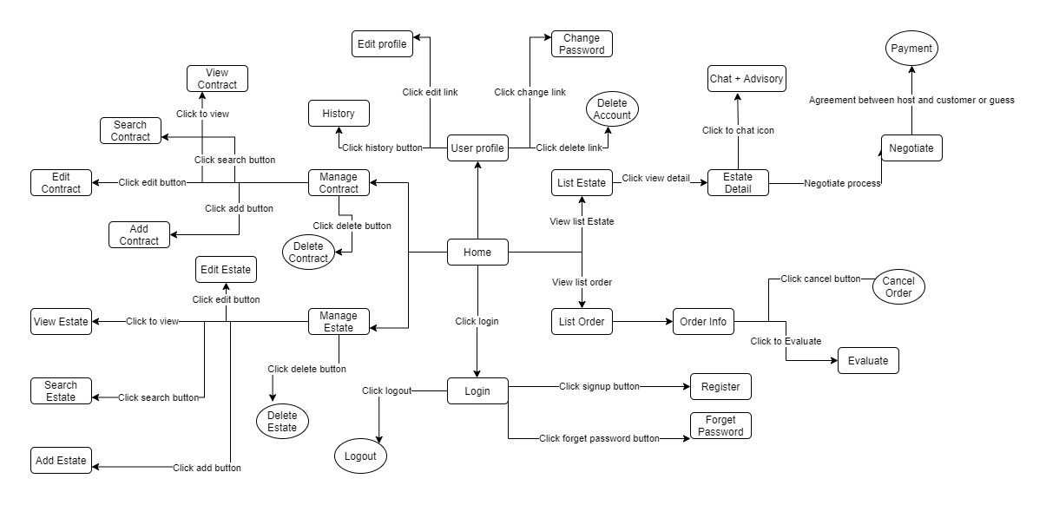

|  |  |  |  |
| --- | --- | --- | --- |
| **#** | **Feature** | **Screen** | **Description** |
| 1 | Change password | Change  password | When the user forgets the password to log in, the screen is displayed, asking the user to enter the information necessary to get the new password back |
| 2 | Edit profile | Edit (User profile) | The information display allows users to edit personal information in profiles |
| 3 | Delete Account | Delete Account | The system confirms that the user is certain to delete the account |
| 4 | View profile | User Profile | Display account information |
| 5 | View History | History | Displays the user's real estate transaction history |
| 6 | Switch user | Switch user | Display window allows users to choose the interface for the broker or the interface for the customer buy real estate project |
| 7 | Home | Home | Home screen |
|  | Add contract | Add contract | Display a page that allow user to enter contract’s information |
| 8 | Delete contract | Delete contract | The system confirm that the user is certain to delete the contract |
|  | Edit contract | Edit contract | The information display allows users to edit information in the contract |
| 8 | Search contract | List contract | Display a list of real estate contract filtered out from the requirements that the user has selected |
| 9 | View contract | Contract detail | Display contract details. |
| 10 | Chat | Chat | Display a chat window between the broker and customer |
| 11 | Order | Order | Request buy a real estate project |
| 12 | Payment | Payment | Select paid forms of payment and verification |
| 13 | View order | List order | Display a list of owned real estate project |
| 14 | View order information | Order info | Display information about the rental application |
| 15 | Evaluate | Evaluate | Display page allows users to rate the real estate project |
| 16 | Cancel order | Cancel order | The system confirms that the user is sure to cancel real estate order |
| 17 | Evaluate | Evaluate | Display a page that allows comments and reviews about rented cars |
| 19 | View list order | List order | Display a list about real estate project order |
| 22 | Delete estate | Delete estate | Delete a real estate project from the system |
| 23 | View estate | View estate | Display a list of real estate project |
| 24 | Add estate | Add estate | Displaying a page that allows user to enter real estate project information |
| 25 | Edit estate | Edit estate | Display page that allows editing real estate information |
| 26 | Delete estate | Delete estate | Display page that allow deleting the real estate project |
| 27 | Login | Login | Show sign-in page |
| 28 | Forgot password | Forgot password | Display a page that allows filling in the information needed to retrieve the password |
| 29 | Register | Register | Show account sign-up page |
| 30 | Logout | Logout | Display the account sign out confirmation window |

## Non-Functional Requirements Specification

### External Interface Requirements

#### User Interfaces

Screen 1: Home

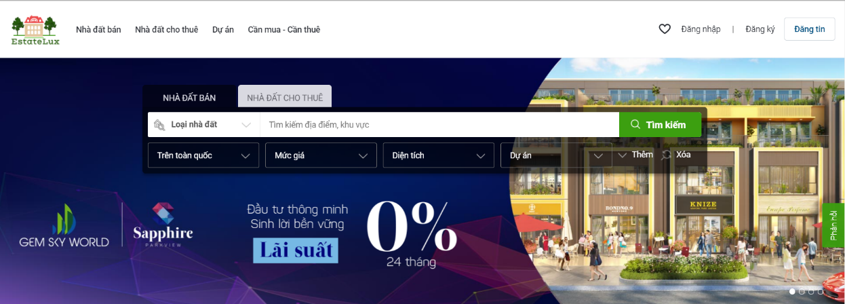

Screen 2: Screen Login and Register

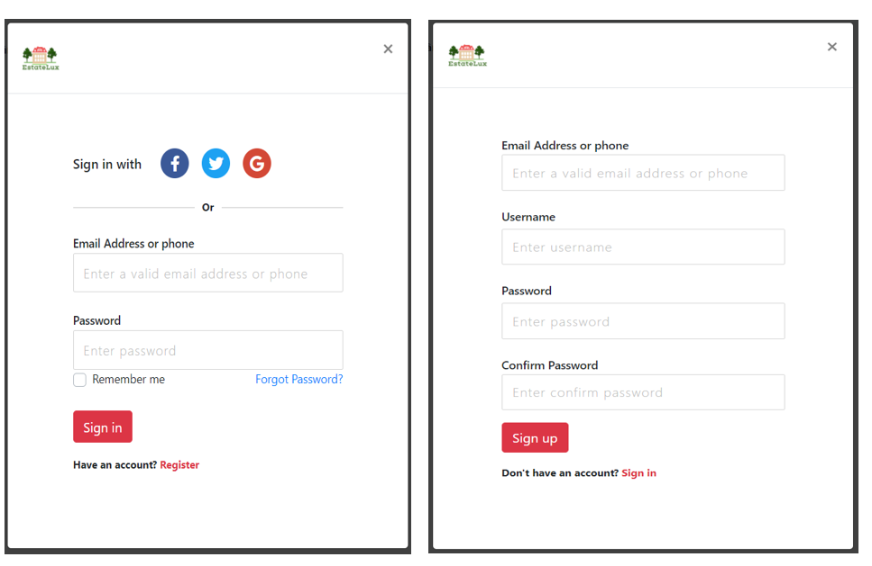

Screen 3: Screen Estate By Place

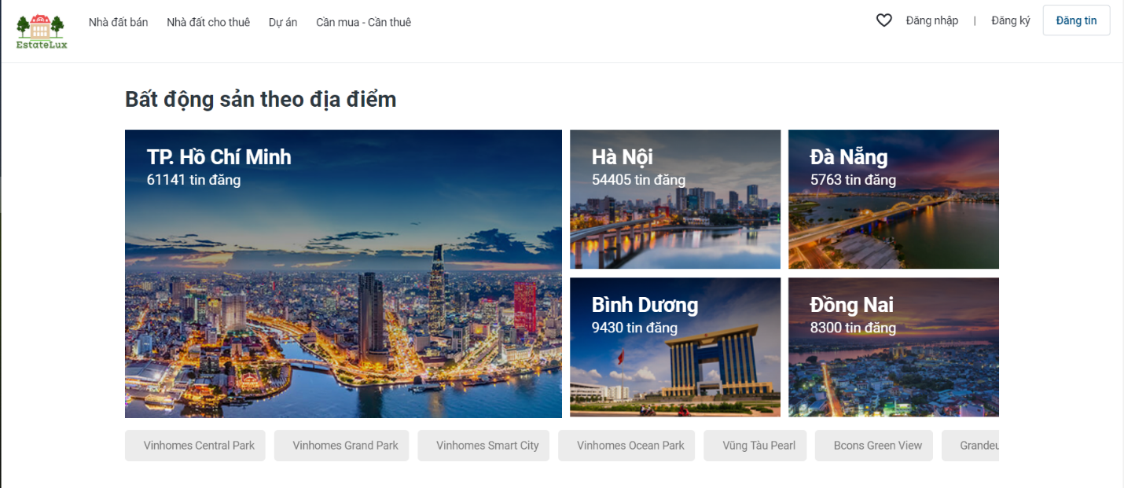

Screen 4: Screen Suggest Estate For You

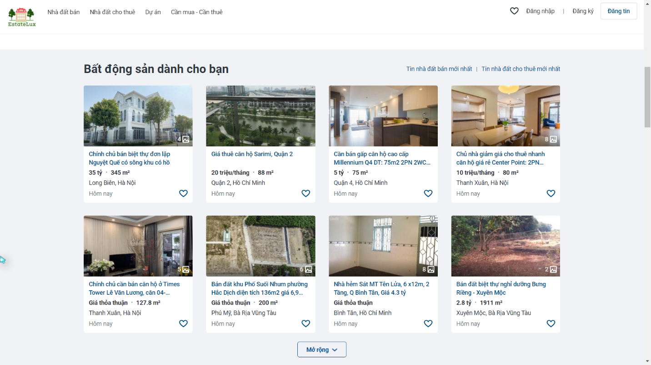

Screen 5: Screen Esate Details

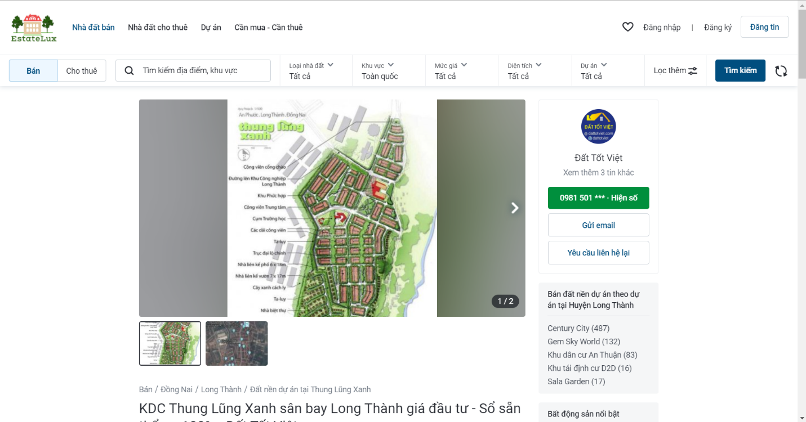

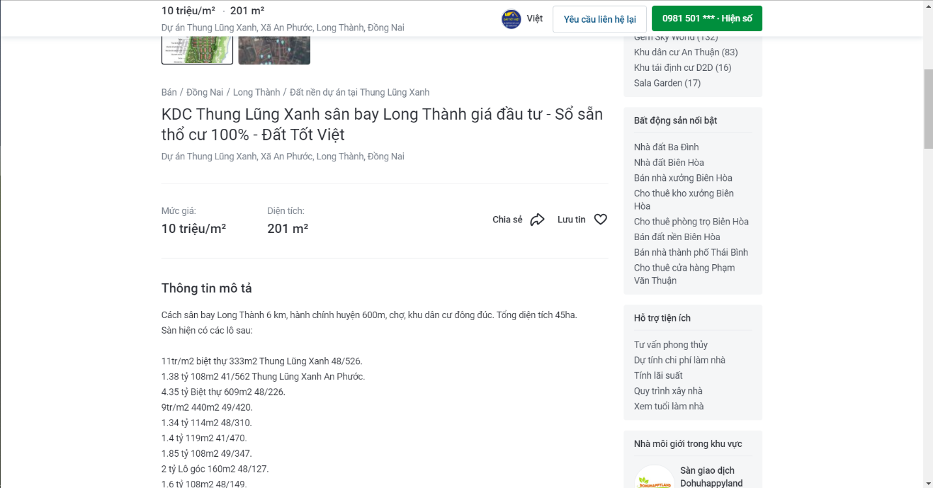

Screen 6: Screen Adding a new Estate for Host and Admin

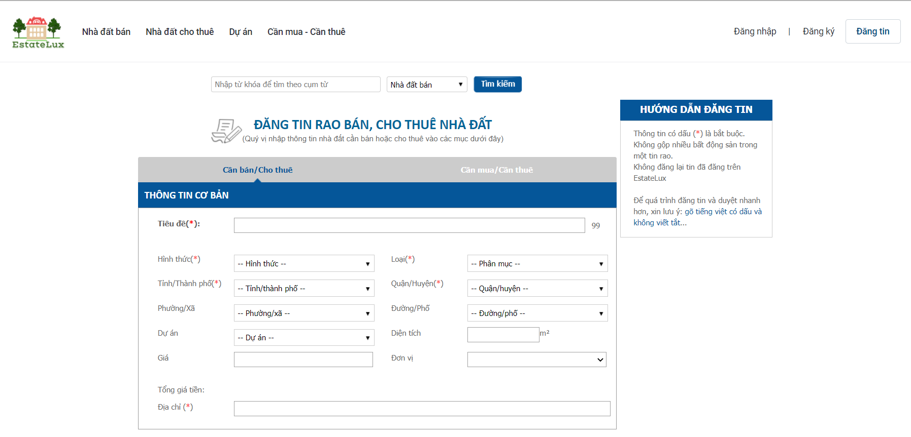

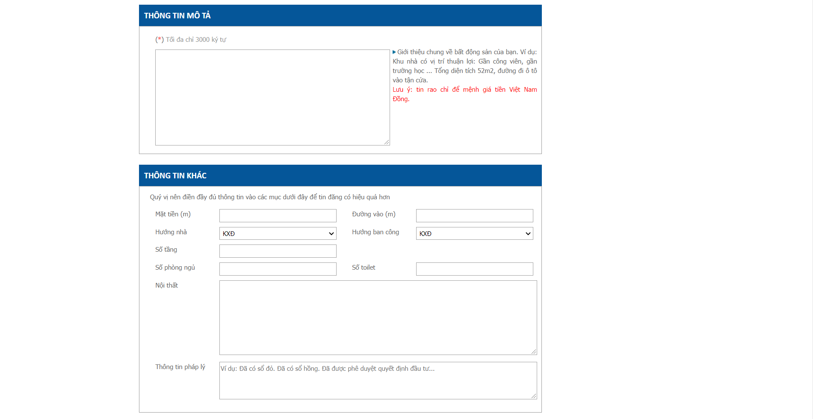

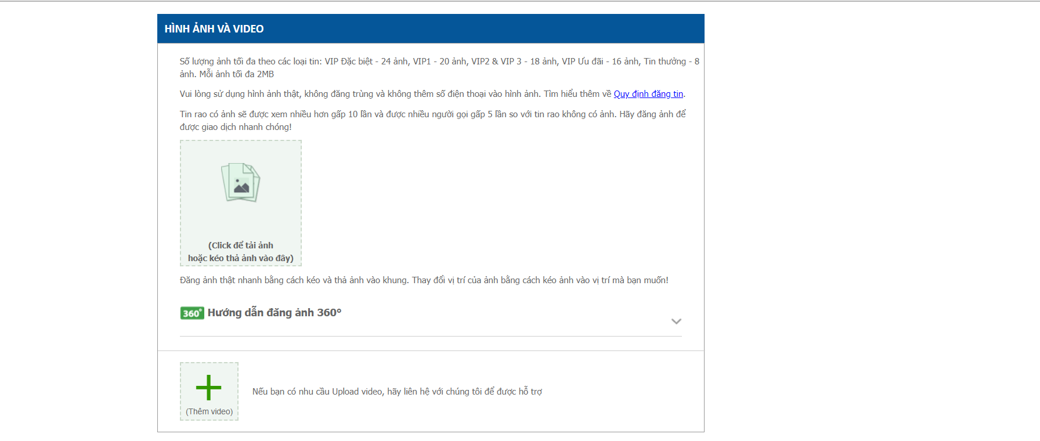

Screen 7: Screen Location

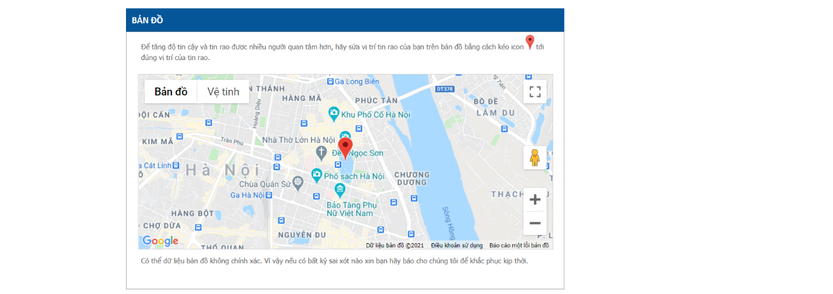

Screen 8: Screen Profile User

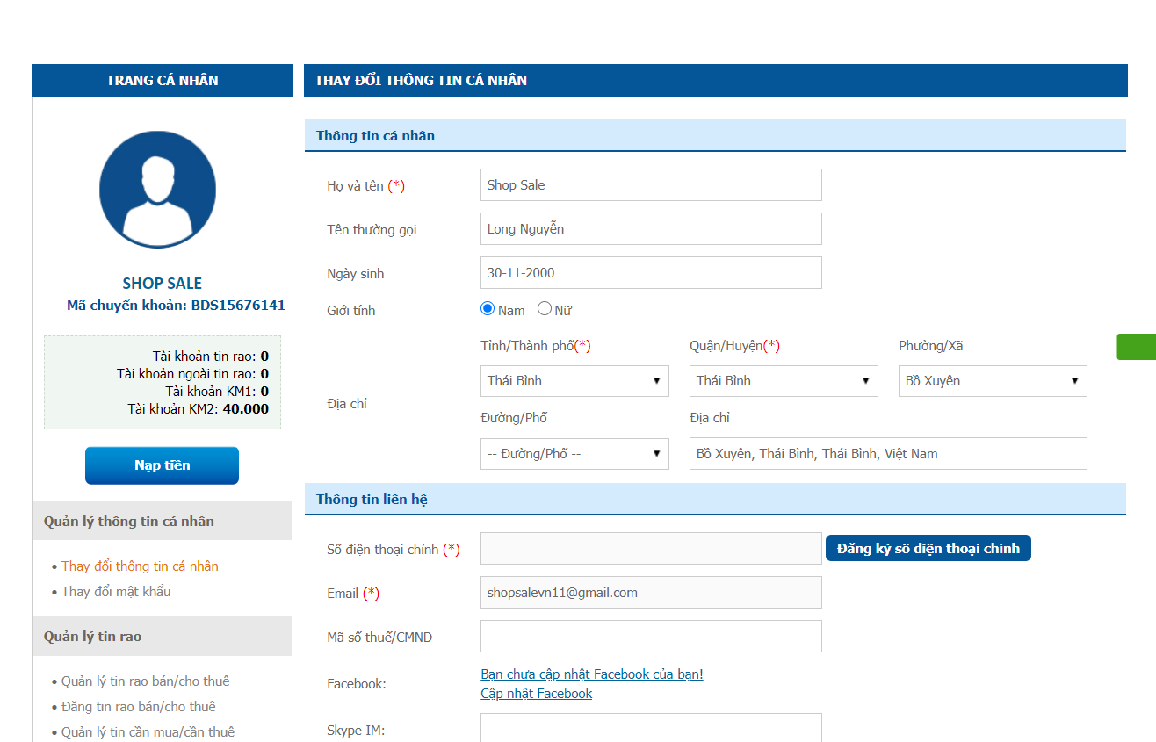

Screen 9: Screen Fillter

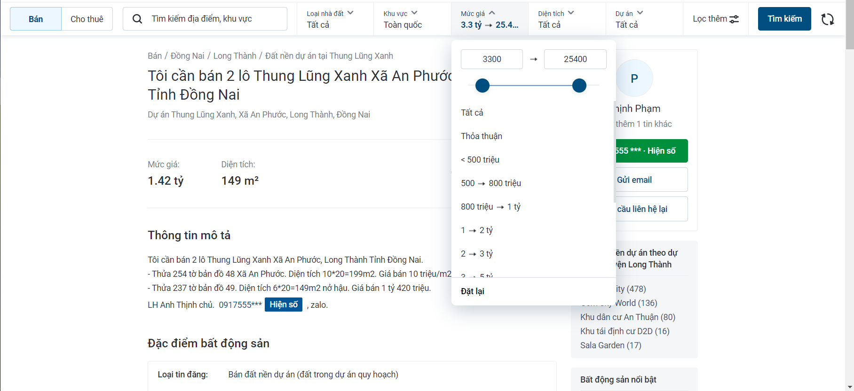

Screen 10: Estate for Rental or Sale

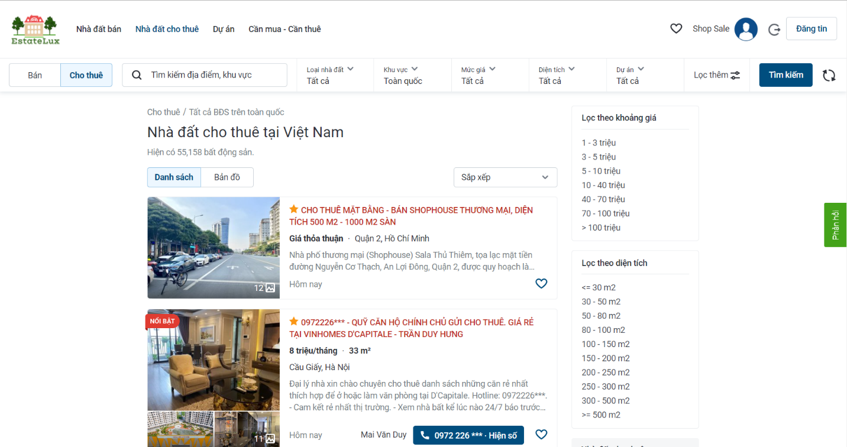

Screen 11: Screen Real Estate - Project

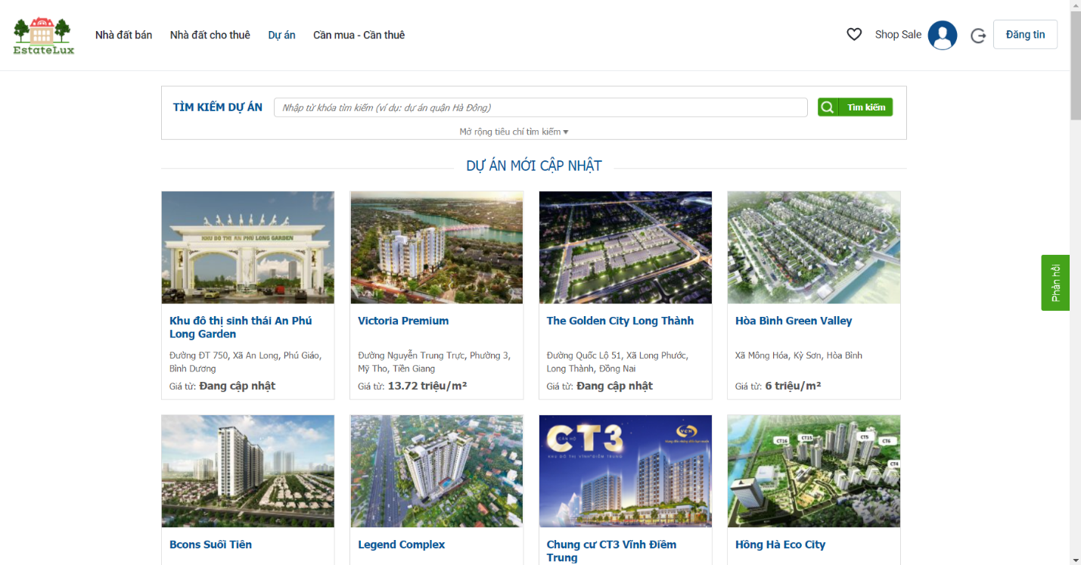

#### Hardware Interfaces

It strongly recommended that user use a desktop device instead of mobile device because some feature may be not work well in mobile in version 1.0 of M&K website. Don’t forget that you must have an internet connection like Wan – Lan.

Recommend that user should use new version of Chrome, Firefox, Safari, Edge. Internet Explorer may be not fully supported this website.

#### Software Interfaces

As it has already been started, M&K run on almost browser with internet on any OS on client side. With server side, all most functions depend on database. See information of database in Appendix.

#### Communications Interfaces

M&K use HTTP for communication over the internet.

### Other Nonfunctional Requirements

#### Performance Requirements

First version 1.0 of M&K website does not require powerful processor, more ram or need card graphic. It will run fast all most feature. But this version just used connection database with 5 database transaction units and 2GB memory from Azure DB. if there are over 500 connections to website, connection to database may be slowly. Speed and bandwidth of connection database should be upgrade in next version.

#### Design constraints

Coding design constraints uses Model-View-Controller pattern.

#### Safety Requirements

If developers are not careful, data in database can be loss. You must remember to save backup data to rollback if something wrong happened. M&K website version 1.0 doesn’t have more feature for admin because if admin lost account administrator, it’s very difficult to rollback data when database is deleted.

#### Security Requirements

Admin never sees another account password. System back-end servers is only accessible by administrator, all database is encrypted.

First version 1.0 is also initialization version so DDOS server may be happened. Delay time access will apply if DDOS happen to decrease number of DDOS happens in the future. Next version must improve plan to defense out of DDOS.

#### Software Quality Attributes

M&K website has quite easy GUI with all features can be access from homepage. User can easy accesses to a feature from header of website. All feedback can be sent to email on the footer of website.

1. Other Requirements